**CBS Primary School,**

Chapel Street,

Dundalk,

Co. Louth.

A91 YF82

Telephone number: 042 9327861

[office@cbsprimarydundalk.ie](mailto:office@cbsprimarydundalk.ie)

**Anti-Bullying Policy**

### Rationale

Children First National Guidance 2017 outlines that bullying can be defined as repeated aggression – verbal, psychological or physical – conducted by an individual or group against others. Children First National Guidance 2017 describes bullying as intentionally aggravating and intimidating behaviour that occurs mainly among children in social environments such as schools. It includes physical aggression, cyberbullying, damage to property, intimidation, isolation/exclusion, name-calling, malicious gossip, and extortion. Bullying can also take the form of identity abuse based on gender, sexual preference, race, ethnicity, and religious factors. With developments in modern technology, children can also be the victims of non-contact bullying via mobile phones, the internet and other personal devices.

In accordance with the requirements of the Education (Welfare) Act 2000 and the code of behaviour guidelines issued by the NEWB (TUSLA), the Board of Management of CBS Primary School has adopted the following anti-bullying policy within the framework of the school's overall code of behaviour. This policy fully complies with the requirements of the Anti-Bullying Procedures for Primary and Post-Primary Schools, which were published in September 2013.

Children First National Guidance 2017 and the Anti-Bullying Procedures provide that in cases of serious instances of bullying where the behaviour is regarded as possibly abusive, a referral may need to be made to Tusla or An Garda Síochána as appropriate. Where school personnel have concerns about a child arising from alleged bullying behaviour but are not sure whether to report the matter to TUSLA, the designated liaison person shall seek advice from Tusla in accordance with the procedures set out in Chapter 5 of Child Protection Procedures for Primary and Post-Primary Schools 2017. The Board of Management of CBS Primary Dundalk recognises the very serious nature of bullying and its negative impact on pupils' lives. It is, therefore, fully committed to the following key principles of best practice in preventing and tackling bullying behaviour:

*(a) A positive school culture and climate which*

* is welcoming of difference and diversity and is based on inclusivity.
* encourages pupils to disclose and discuss incidents of bullying behaviour in a non-threatening environment; and
* promotes respectful relationships across the school community.

*(b) Effective leadership*

*(c) A school-wide approach*

*(d) A shared understanding of what bullying is and its impact*

*(e) Implementation of education and prevention strategies (including awareness-raising measures) that-*

* build empathy, respect, and resilience in pupils; and
* explicitly address the issues of cyber-bullying and identity-based bullying, including homophobic and transphobic bullying.
* effective supervision and monitoring of pupils.

*(f) Effective supervision and monitoring of pupils*

*(g) Supports for staff*

*(h) Consistent recording, investigation, and follow-up of bullying behaviour (including use of established intervention strategies); and*

*(i) Ongoing evaluation of the effectiveness of the anti-bullying policy.*

**Definition of bullying**

In accordance with the *Anti-bullying Procedures for Primary and Post-Primary Schools,* bullying is defined as follows:

*Bullying is an unwanted negative behaviour, verbal, psychological or physical, conducted by an individual or group against another person (or persons) and which* ***is repeated over time.***

The following types of bullying behaviour are included in the definition of bullying:

* deliberate exclusion, malicious gossip, and other forms of relational bullying,
* cyber-bullying
* Identity-based bullying such as homophobic bullying, racist bullying, bullying based on a person's membership of the Traveller community and bullying of those with disabilities or special educational needs.

### Isolated or once-off incidents of intentional negative behaviour, including a once-off offensive or hurtful text message or other private messaging, do not fall within the definition of bullying and should be dealt with, as appropriate, in accordance with the school's code of behaviour.

However, in the context of this policy,

Placing a once-off offensive or hurtful public message, image or statement on a social network site or another public forum where that message, image or statement can be viewed and repeated by other people will be regarded as bullying behaviour.

Negative behaviour that does not meet this definition of bullying will be dealt with in

accordance with the school's code of behaviour. Additional information on different types of bullying is set out in Section 2 of the *Anti-Bullying Procedures for Primary and Post-Primary Schools* (See Appendix 1)

**Bullying Prevention**

The education and prevention strategies (including strategies specifically aimed at cyberbullying, homophobic and transphobic bullying) that the school will use are as follows (see Section 6.5 of the Anti-Bullying Procedures for Primary and Post-Primary Schools):

**School-wide approach**

* A school-wide approach to fostering respect for all members of the school community.
* The promotion of the value of diversity to address issues of prejudice and stereotyping and highlight the unacceptability of bullying behaviour.
* The fostering and enhancing of all our pupils' self-esteem through curricular and extracurricular activities. Pupils will be provided opportunities to develop a positive sense of self-worth through formal and informal interactions.
* Whole-staff professional development on bullying ensures that all staff develop an awareness of what bullying is, how it impacts pupils' lives, and the need to respond to it- prevention and intervention.
* Supervising and monitoring classrooms, corridors, school grounds, school tours and extracurricular activities. Non-teaching and ancillary staff will be encouraged to be vigilant and report issues to relevant teachers. Supervision will also apply to monitoring student use of communication technology within the school (See Acceptable Use Policy).
* Development of a KiVa slogan/chant for the school to be learned and promoted school-wide for the KiVa launch. As a key principle of KiVa, the victims should feel that they are heard and helped by the adults at the school. KiVa posters are displayed in common areas of the school as a reminder that we are a KiVa school, we support each other and do not tolerate bullying.
* The school's anti-bullying policy is discussed with incoming pupils' parent(s)/guardian(s) and is given a copy as part of the Code of Behaviour.
* The school's anti-bullying policy will also be sent to parents/guardians via Aladdin and is available on the school's website.
* The implementation of regular whole-school awareness measures, which include:
* Friendship and Kindness Month (November)
* KiVa: Raise awareness and promote the principles of KiVa.
* Make all pupils and staff aware of KiVa team members.
* Regular reminders at school assemblies.
* KiVa Parent information event.
* KiVa lessons from 1st-6th class.
* Stay Safe lessons.
* Circle time activities
* Implementing NEPS programmes, Friends for Life, Fun Friends, and Incredible Years.
* Encourage a culture of telling, emphasising the importance of bystanders. In that way, pupils will gain confidence in 'telling'. It should be clear to all pupils that when they report bullying incidents, they are not considered to be telling tales but are behaving responsibly.
* Pupils should understand that there are no innocent bystanders and that all incidents of bullying behaviour must be reported to a teacher. Influencing the behaviour of bystanders can reduce the rewards gained by the bullies and, consequently, their motivation to bully in the first place.
* Ensuring that pupils know who to tell and how to tell.
* A direct approach to the teacher at an appropriate time, for example, after class.
* Hand notes up with homework.
* Make a phone call to the school or a trusted teacher in the school.
* Anti-bully or Worry Box
* Get a parent(s)/guardian(s) or friend to tell on your behalf.
* Administer a confidential questionnaire to pupils in senior classes.
* Guidance for Staff, Parents and Teachers in the area of Bullying prevention shall be shared with members of the school community (See Appendix 2).

**Implementation of Curricula:**

* Full implementation of the SPHE curriculum.
* School-wide delivery of lessons on bullying from evidence-based programmes, including:
* Stay Safe Programme
* Relationships and Sexuality Education Programme (RSE)
* KiVa Anti-Bullying Programme
* Additional programmes delivered in targeted classes include:
* Walk Tall Programme
* Be Safe, Be WebWise
* Friends for Life
* Fun Friends
* Safe Hands (Women's Aid)
* Delivery of the Garda SPHE Programmes when available. These lessons delivered by the Community Garda cover issues such as personal safety and cyberbullying.
* Circle time activities are carried out at all class levels to promote friendship, self-awareness, sharing and kind practice.
* The school will specifically consider the additional needs of pupils with regard to programme implementation and the development of skills and strategies to enable all pupils to respond appropriately. If necessary, the SET team will help to deliver/reinforce key messages from Stay Safe/KiVa lessons.

**Links to other policies**

• Code of Behaviour

• Child Safeguarding Statement

• DEIS Plan

• Special Educational Needs

• Acceptable Use Policy

• Health and Safety

* RSE

**Persons responsible for dealing with bullying incidents.**

* Any teacher can act as a relevant teacher if circumstances warrant it.
* Class teachers/SET
* KiVa Team – Emer Mc Nulty (coordinator), Sinead Mc Nally, Ann O'Grady, Niamh Corcoran, Niamh O Connor
* Principal – Eileen Hart
* Deputy Principal – Petrina Hanratty

**Tackling bullying incidents**

In addition to the programmes and policies included, we also use the KiVa Anti-Bullying Programme. This programme supplements our teaching and underpins our commitment to creating an Anti-Bullying environment within our school. The programme was developed in Finland and has been shown in large-scale studies to reduce bullying in schools effectively.

### The aims of the KiVa programme are:

* **To reduce bullying**
* **To effectively tackle bullying that comes to the attention of the school.**
* **To prevent new bullying incidents from occurring**
* **To minimise the negative effects caused by bullying.**

KiVa lessons include discussions, group work, short films, and role-play about bullying. The children typically learn about respecting others, including everyone, how to function in a group and how to help someone who is being bullied. Many lessons concentrate on a group's role in maintaining or stopping bullying; the students think about and practice different ways to resist bullying. The lessons complement the KiVa computer game, where students practice anti-bullying actions in a virtual school. The curriculum work aims to educate students about their role in stopping bullying. Instead of being 'silent approvers' or 'assistants to the bully', children start to support the victimised child, developing a shared sense of responsibility within the class. At the end of each lesson, each class develops and agrees on an anti-bullying class rule. KiVa posters/displays in the school hall ensure that the program is constantly visible.

All adults at the school have received basic awareness training about bullying (through KiVa) and will report any concerns to the KiVa Team. The KiVa Team notifies parents of all those involved in a verified bullying situation.

**Procedures for investigating and dealing with bullying.**

**Reporting Bullying behaviour**

The primary aim in investigating and dealing with bullying is to resolve any issues and to restore, as far as is practicable, the relationships of the parties involved (rather than apportion blame).

* Any pupil or parent(s)/guardian(s) may bring a bullying incident to the relevant teacher in the school.
* Parents are encouraged to make an appointment to speak with relevant class teachers if they suspect their child is being bullied.
* All reports of alleged bullying, including anonymous reports, will be investigated, and dealt with by the KiVa team.
* Teaching and non-teaching staff such as secretaries, special needs assistants (SNAs), caretakers and cleaners must report any bullying behaviour witnessed or mentioned to the relevant teacher.
* A suspicion of bullying should be raised with the relevant class teacher first and then referred to the KiVa team (should the screening process indicate bullying).

**Investigating and dealing with reported bullying incidents:**

* At CBS Primary, we note that some children engage in low-level negative behaviours towards others.  These behaviours may be the same as behaviours which can be deemed as bullying but do not always fall under the definition of bullying, e.g., a child may laugh at another child, this may be hurtful but a once-off experience or it can be part of an ongoing pattern of behaviour that may amount to bullying.
* Teachers monitor these behaviours as part of their responsibilities.  In CBS Primary, staff are encouraged to keep a note of behaviours when or if they see a pattern emerging. If necessary, a KiVa screening form may be filled out and a referral made to the KiVa team. However, minor, or once-off occurrences of negative behaviour may not be recorded and can generally be dealt with informally using the class behaviour/reward system.
* Where a behaviour/s has been repeated over time and bullying is suspected, the KiVa process will begin.
* Instances of misbehaviour will result in sanctions (as appropriate), including where incidents occur in the context of bullying (see Code of Behaviour).
* Serious incidents involving bullying (including where a child is in immediate danger/a criminal offence is committed) shall forego the KiVa process and be dealt with directly by the principal. The principal will contact the parents of the students involved. The template for recording bullying behaviour (Appendix 3) shall be filled out as a record and retained by the principal.
* As per the Children First National Guidance 2017 and the Anti-Bullying Procedures, in instances of bullying where the behaviour is regarded as potentially abusive, a referral may need to be made to TUSLA or An Garda Síochána, as appropriate.
* Where cyberbullying or online abuse is reported to the school (and has occurred outside school hours), the relevant parents will be contacted to inform them of the issue. Parents will be reminded that it is advisable to monitor children's activity online and that a child should not have access to apps or social media until they are the specified legal age. See also the school's AUP (Acceptable Use Policy). Internet safety links are available on our school website under the 'Information for Parents' section.

# **Informal‐ pre‐determination that bullying has occurred.**

**The KiVa Process:**

CBS Primary Dundalk has a dedicated task force to tackle bullying, the 'KiVa Team'. The team consists of six adults in school who have been specially trained to tackle bullying incidents. The KiVa team shall wear high-vis KiVa vests when working officially as KiVa team members. This will also remind pupils that KiVa is active and ongoing in our school and that bullying will not be tolerated.

* If a case of bullying is suspected or a parent or student reports a case of bullying, the relevant teacher will fill out a screening form (See Appendix 4). The screening process will help determine if it is bullying, a conflict, or a fight between children.
* All cases that fulfil the bullying criteria are dealt with systematically by the KiVa Team, and all children involved will be spoken to individually (both the victim and the child/children involved in bullying). At least two members of the KiVa team shall be present at each meeting. Notes will also be taken, and the KiVa Coordinator will keep a record.
* All children involved in the bullying (not the victim) meet as a group and agree on how they will change their behaviour.
* Support for the victim is also identified during their meeting with the KiVa Team.
* Follow-up discussions with all students occur after an agreed amount of time to ensure things are improving for the victim.
* A complete summary of the KiVa steps involved in handling bullying cases can be found in Appendix 5.
* In the event that the KiVa process has not resolved a bullying case, the case will be referred to the principal.

**Formal Stage 1: determination that bullying has occurred.**

If it is established by the relevant teacher that bullying has occurred, the relevant teacher must keep appropriate records which will assist his/her efforts to resolve the issues and restore, as far as is practicable the relationships of the parties involved.

The school in consultation with the relevant teacher/s should develop a protocol for the storage of all records retained by the relevant teacher.

**Formal Stage 2: Appendix 3 (From DES Procedures)**

The relevant teacher must use the recording template at Appendix 3 to record the bullying behaviour in the following circumstances:

* In cases where he/she considers that the bullying behaviour has not been adequately and appropriately addressed within 20 school days after he/she has determined that bullying behaviour occurred and
* Where the school has decided as part of its anti-bullying policy that in certain circumstances bullying behaviour must be recorded and reported immediately to the principal or deputy principal as applicable. The school should list behaviours that must be recorded and reported immediately to the principal. See the school’s code of behaviour.
* When the recording template is used, it must be retained by the relevant teacher in question and a copy maintained by the principal. Due consideration needs to be given to where these records are kept, who has access to them and how long they will be retained. Decisions around record keeping will be stored as per our GDPR policy.

**Supports for children affected by bullying.**

*Supporting the child who has been bullied:*

* Ensure that the child who has been bullied (along with their parents/guardians) knows there will be a determined effort to stop the bullying.
* Partaking in confidence-building exercises, e.g., writing down good things about themselves.
* Ensure the bullied child accepts and acknowledges that they are not at fault.
* Build self-esteem: Help the student master a new skill, include them in a new social or sports group, and encourage them to take on a new responsibility, e.g. buddy reading, green schools committee, other school-related activities.
* Ensure the student has peer support (The class teacher and KiVa team will identify suitable children to support the victim).
* Provide the student with self-protective strategies: Ensure the child knows the 'Stay Safe' rules: Say No/Stop, get away, Tell an adult (& keep telling if necessary). Rehearse scenarios, e.g., Keep calm and walk away. Talk through individual strategies for that child.
* The KiVa team will follow up after the intervention has finished. The class teacher will continually monitor the child and offer support as needed.
* Refer to HSCL, School completion officer or outside agencies where appropriate.

**Supporting the child involved in Bullying:**

* Discussions with parents/guardians on how to best support their child.
* Determine if there are issues that may be contributing to the behaviour, e.g., problems at home/difficulties making friends/poor self-esteem.
* Build self-esteem: Help the student master a new skill, include them in a new social or sports group, and encourage them to take on a new responsibility, e.g., buddy reading, green schools committee.
* The school will implement appropriate strategies (depending on the child's needs).
* Refer to HSCL, School completion officer or outside agencies where appropriate, e.g., CAMHS, NEPS.
* Ensure regular follow-up after the interventions have finished. The class teacher will continually monitor and offer support as needed.

**Supervision and Monitoring of Pupils**:

The Board of Management confirms that appropriate supervision and monitoring policies and practices are in place to prevent and deal with bullying behaviour and facilitate early intervention where possible.

**Prevention of Harassment:**

The Board of Management confirms that the school will, in accordance with its obligations under equality legislation, take all such steps that are reasonably practicable to prevent the sexual harassment of pupils or staff or the harassment of pupils or staff on any of the nine grounds specified, i.e. gender including transgender, civil status, family status, sexual orientation, religion, age, disability, race and membership of the Traveller community.

* This policy has been made available to school personnel and will be published on the school website. It is also available on request. A copy of this policy will be made available to the DES and the school patron if requested.
* This policy and its implementation will be reviewed by the Board of Management every school year. Written notification that the review has been completed will be made available to school personnel, published on the school website, and available on request. A record of the review and its outcome will be made available, if requested, to the patron and the Department.

**The Board of Management reviewed and updated this policy in October 2024.**

Signed: _______________________________ Signed: _________________________

(Chairperson of Board of Management) (Principal)

Date: ______________ Date: __________________

**Appendix 1**

**Types of bullying**

The following are some of the types of bullying behaviour that can occur amongst pupils:

**Physical aggression:** This behaviour includes pushing, shoving, punching, kicking, poking and tripping people. It may also take the form of severe physical assault. While pupils often engage in 'mess fights', they can sometimes be used as a disguise for physical harassment or inflicting pain.

**Intimidation:** Some bullying behaviour takes the form of intimidation: it may be based on the use of very aggressive body language with the voice being used as a weapon. Particularly upsetting can be a facial expression which conveys aggression and/or dislike.

**Isolation/exclusion and other relational bullying:** This occurs where a certain person is deliberately isolated, excluded or ignored by some or all of the class group. This practice is usually initiated by the person engaged in bullying behaviour and can be difficult to detect. It may be accompanied by writing insulting remarks about the pupil in public places, by passing around notes about or drawings of the pupil or by whispering insults about them loud enough to be heard. Relational bullying occurs when a person's attempts to socialise and form relationships with peers are repeatedly rejected or undermined. One of the most common forms includes control: "Do this or I won't be your friend anymore" (implied or stated); a group ganging up against one 10 person (girl or boy); non-verbal gesturing; malicious gossip; spreading rumours about a person or giving them the "silent treatment".

**Cyber-bullying:** This type of bullying is increasingly common and is continuously evolving. It is bullying carried out through the use of information and communication technologies such as text, social network sites, e-mail, instant messaging (IM), apps, gaming sites, chat-rooms and other online technologies. Being the target of inappropriate or hurtful messages is the most common form of online bullying. As cyber-bullying uses technology to perpetrate bullying behaviour and does not require face to face contact, cyber-bullying can occur at any time (day or night). Many forms of bullying can be facilitated through cyber-bullying. For example, a target may be sent homophobic text messages or pictures may be posted with negative comments about a person's sexuality, appearance etc.

**Name calling:** Persistent name-calling directed at the same individual(s) which hurts, insults or humiliates should be regarded as a form of bullying behaviour. Often name calling of this type refers to physical appearance, e.g., size or clothes worn. Accent or distinctive voice characteristics may attract negative attention. Academic ability can also provoke name calling. This tends to operate at two extremes. There are those who are singled out for attention because they are perceived to be weak academically. At the other extreme there are those who, because they are perceived as high achievers, are also targeted.

**Damage to property:** Personal property can be the focus of attention for bullying behaviour. This may result in damage to clothing, mobile phone or other devices, school books and other learning material or interference with a pupil's locker or bicycle. The contents of school bags and pencil cases may be scattered on the floor. Items of personal property may be defaced, broken, stolen or hidden.

**Extortion:** Demands for money may be made, often accompanied by threats (sometimes carried out in the event of the targeted pupil not delivering on the demand). A pupil may also be forced into theft of property for delivery to another who is engaged in bullying behaviour.

**Appendix 2**

**Guidance for relevant parties in the prevention of bullying**

### What to do if someone is being bullied:

When someone is being bullied, act. Watching and doing nothing can suggest support for the bully.

If you see someone else being bullied, tell an adult. (Do not try to intervene)

If you witness severe bullying, e.g., physical violence, inform an adult immediately.

You can write your concerns down and put it in a "Worry Box."

**Staff**

To ignore is to condone. Listen carefully and, if necessary, make a note of the incident.

All staff to be aware of the times and areas when and where bullying could happen e.g., toilets, areas of the playground.

Offer the victim immediate support and help.

Ensure all pupils are aware that there are consequences to any anti-social behaviour and that incidents will be dealt with.

Make the unacceptable nature of the behaviour, and the consequences of any repetition, clear to the bully.

Stress that it is the "behaviour" and not the pupil that is unacceptable.

Try to support the bully in changing the behaviour, by using practical, attainable targets.

**Pupils**

Children need to know and use "Stay Safe" rules (as taught in Stay Safe lessons)

1. Say No/Stop. (Clarify that you are not happy with the unacceptable behaviour)
2. Get away (Remove yourself from the dangerous/upsetting situation).
3. Tell an adult. Keep telling until the issue is addressed.

**Parents**

Watch for signs of distress in your children, e.g., unwillingness to attend school, headaches, illnesses, missing personal items, requests for money, damaged clothes etc. It may be manifested as stomach pains, sleeping problems and tiredness.

Listen when they talk to you about their social life, e.g., friends, playtimes, walking to and from school.

Do not assume all arguments or incidents equate to "bullying". Bullying is persistent/repeated anti-social behaviour.

If you think your child is being bullied, inform the school, and they will use the Kiva screening form.

If necessary, keep a written record.

Do not encourage your child to "hit back". It may make matters worse.

Regularly monitor your children's behaviour online.

Do not allow your child/children to use social media/apps until they are the specified legal age.

# **Appendix 3**

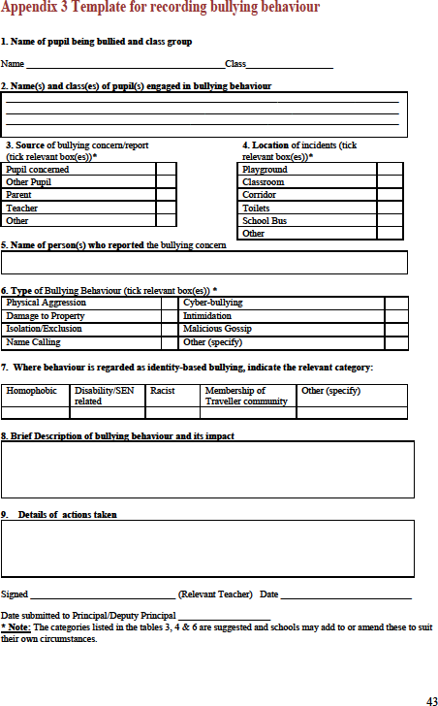**Template for dealing with bullying behaviour**

**Appendix 4**

# **Appendix 4**

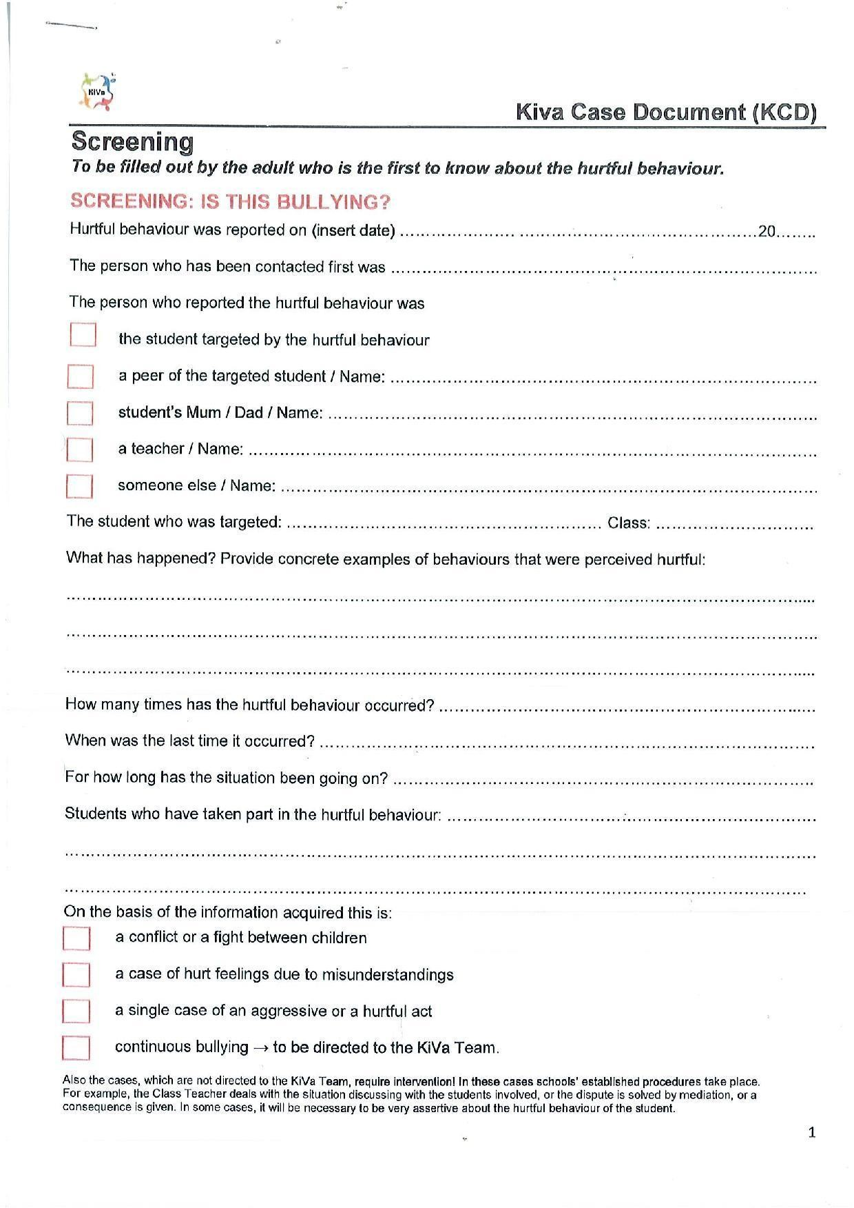**KiVa Screening Form**

**KiVa Steps in dealing with bullying cases**

**Step 1: Screening-Is it systematic**

6. KiVa team-Follow-up discussion with the students who have taken part in bullying (& the bullied student if he/she wishes to attend). ‘How do we ensure the bullying has stopped for good?

1. KiVa team-Discussion with the bullied student. Reassurance given that the KiVa team will help sort it out.

5. KiVa team-Follow up discussion with the bullied student. Has the situation improved?

3. KiVa team-Group discussion with the students who have taken part in bullying. What have they committed to do?

4. KiVa team-Check if class teacher has held the discussions

2. KiVa team-Individual discussions with the student/s who have taken part in bullying.

Yes

No

The Class teacher sorts it out

Class Teacher

Discussion with a few classmates of the bullied student (to act as a support network)-

‘Your help is needed’